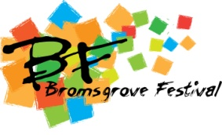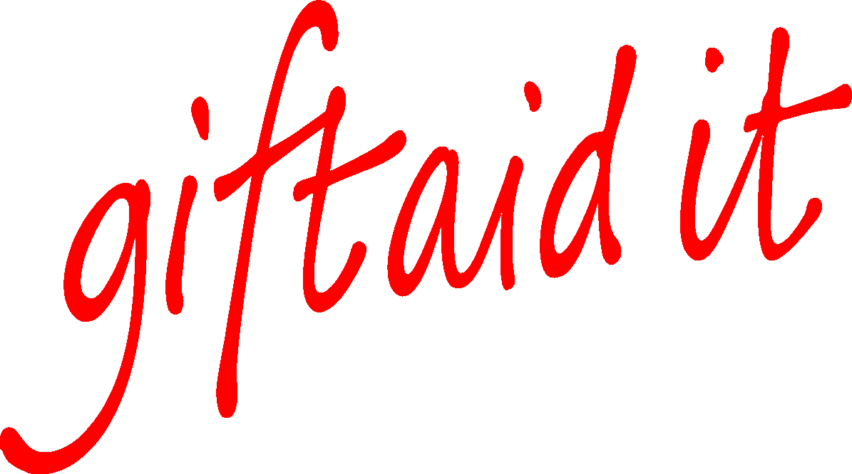
It’s easy for you and very important for us.
Gift Aid makes a real difference.

Please treat the enclosed gift of £ ----------- or the amount of my bank standing order to Bromsgrove Festival as a Gift Aid donation for this tax year and for future years.

Declaration

I confirm I have paid (or will pay) an amount of Income Tax and/or Capital Gains Tax for the current tax year (6 April to 5 April) and for future tax years that is at least equal to the amount of tax that will be reclaimed by all the Charities/Community Amateur Sports Clubs (CASCs) to which I have donated during the current tax year and future tax years under the Gift Aid Scheme.
I understand that other taxes such as VAT and Council Tax do not qualify. I understand the charity will reclaim 25p of tax on every £1 that I have given.

My details:

Title ------- First name or initial(s) -----------------------------------------------

Surname ------------------------------------------------------------------------------

Full Home address ------------------------------------------------------------------
------------------------------------------------------------------------------------------
Postcode ------------

Date --------------- Signature -----------------------------------------------

If you pay Income Tax at the higher or additional rate and want to receive the additional tax relief due to you, you must include all your Gift Aid donations on your Self Assessment tax return or ask HM Revenue and Customs to adjust your tax code.

Please notify the charity or CASC if you:
- Want to cancel this declaration
- Change your name or home address
- No longer pay sufficient tax on your income and/or capital gains

Bromsgrove Festival Limited, c/o Artrix Arts Centre, School Drive, Bromsgrove, Worcestershire, B60 1AX.

Bromsgrove Festival Limited is a registered charity, number 250241

