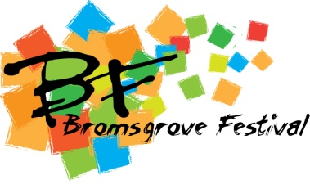

Supporting the Bromsgrove Festival

Patrons and Festival Friends
The generosity of individual, corporate and charitable supporters has enabled the Bromsgrove Festival to build up over the years a distinguished reputation for artistic excellence. In order to revitalise the Festival and develop it further by widening the range of artistic activity and involving the local community, the Bromsgrove Festival is constantly looking for fresh sources of funding to secure a bright future.

Patron

Become a member of this dedicated group and help ensure the continued success of the Bromsgrove Festival. For the 2015 Festival, the cost of being a Patron is again a minimum of £250 which is eligible for Gift Aid. This will provide you with the following benefits:-
- Two reserved tickets for a pre Festival Candlelight Soiree with the Midland Sinfonia at Hanbury Hall on Friday June 12th 2015
- Two reserved tickets for a reception and choral concert by the Ex Cathedra Academies in the chapel at The Grafton Manor Hotel on Tuesday June 23rd 2015
- A postal copy of the souvenir programme
- Special listing in the souvenir programme

Festival Friend
Be part of our special group of supporters by becoming a Festival Friend for an annual subscription of £25, which is eligible for Gift Aid. For this you will be afforded the following benefits:-
- A postal copy of the souvenir programme
- Listing in the souvenir programme
For more information please contact us at info@bromsgrovefestival.co.uk or write to us at Bromsgrove Festival Limited, c/o Artrix Arts Centre, School Drive, Bromsgrove, B60 1AX. To become a Patron or Festival Friend, please complete the attached Gift Aid form and return it with your subscription to the address above. If you wish to set up a standing order for payment in future years, please contact us by e mail or at the address above.

